Create header and line application
- Navigate to make.powerapps.com and select option to Start with a page design.
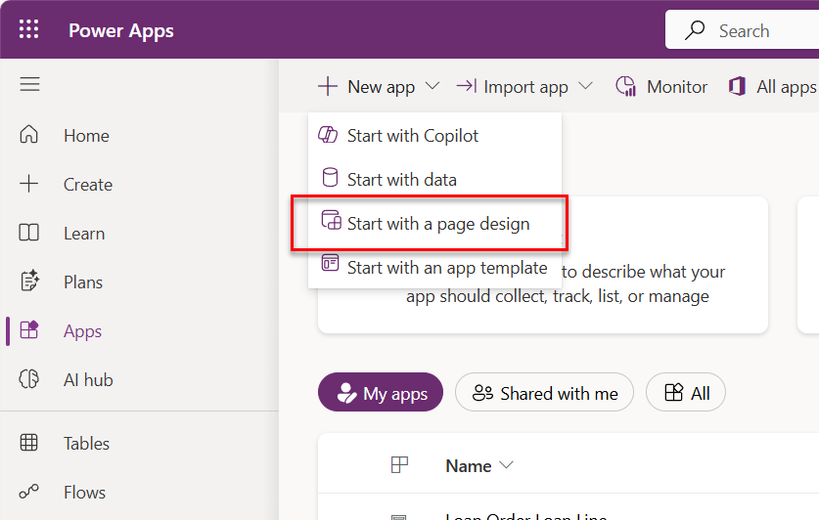
- Select view and form.

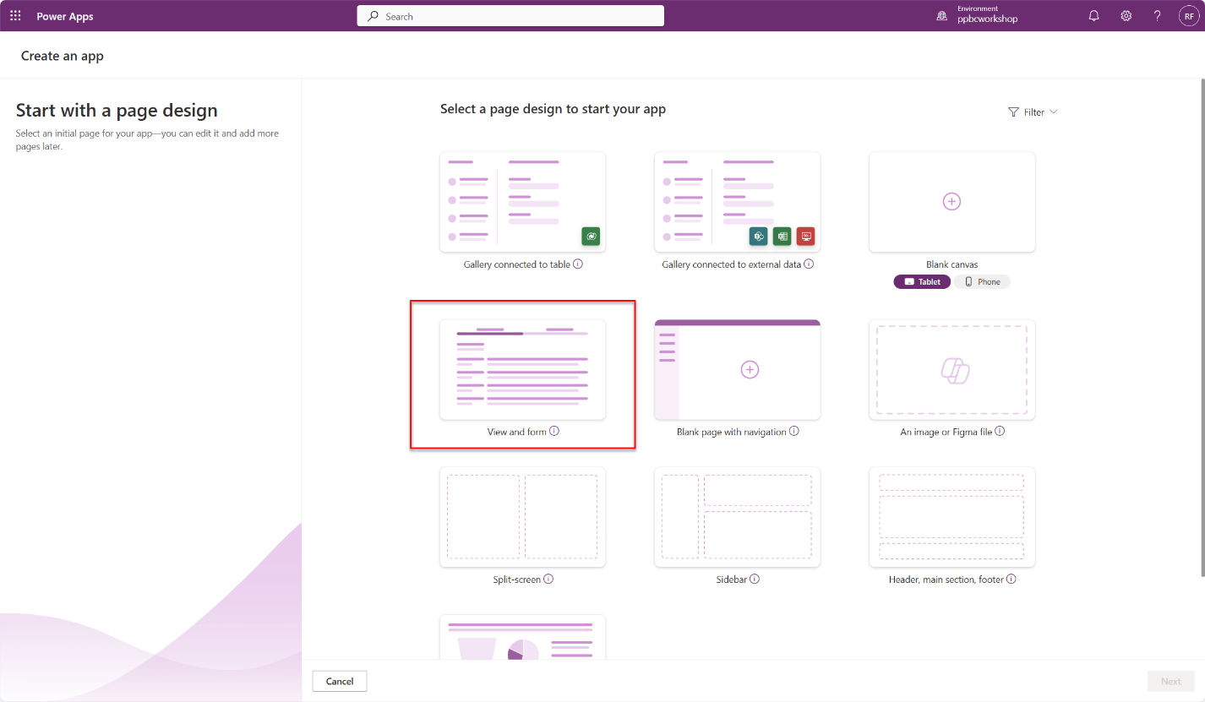
- Give your app a name
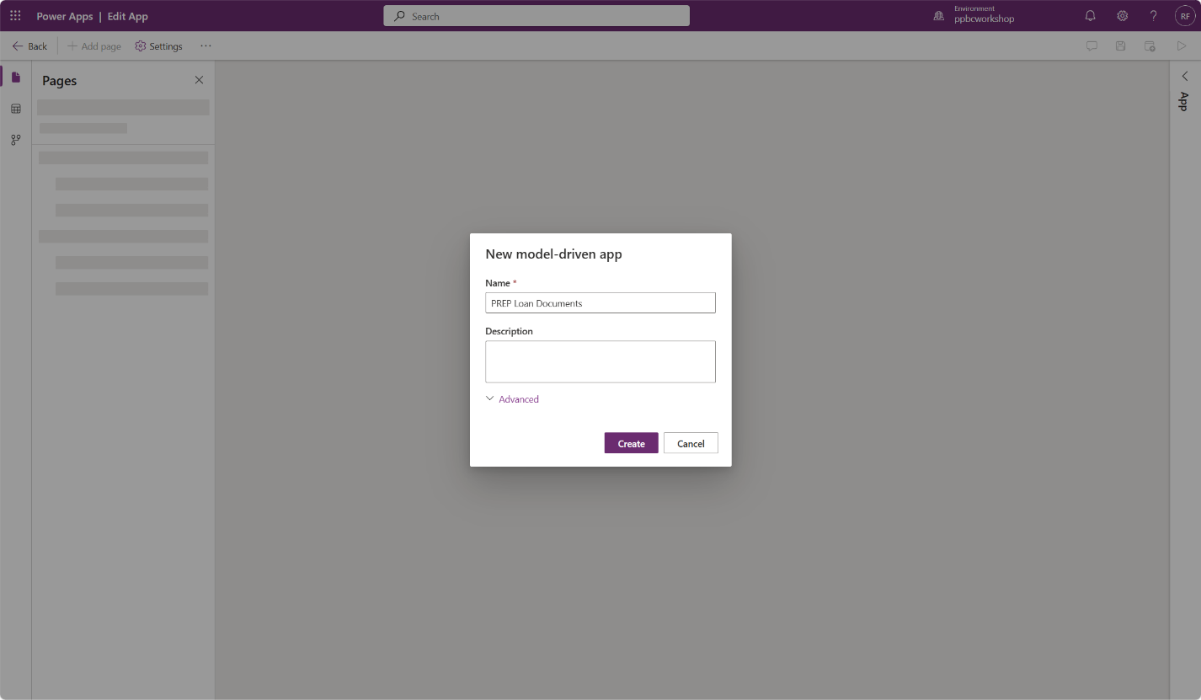
- Select table that represents header table (Loan Order)
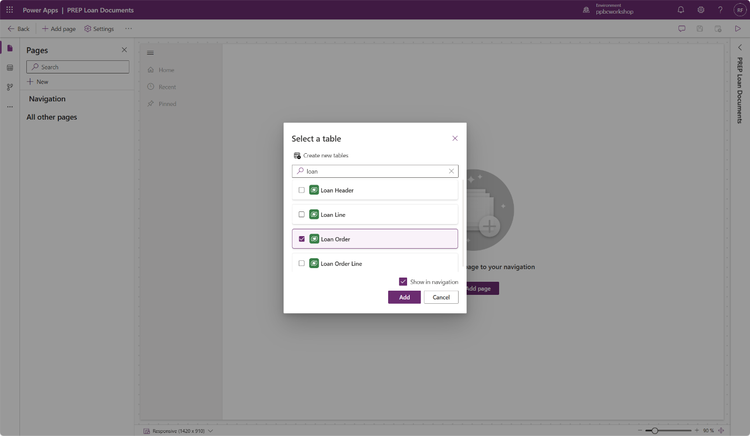
- Select and edit Loan Orders Form
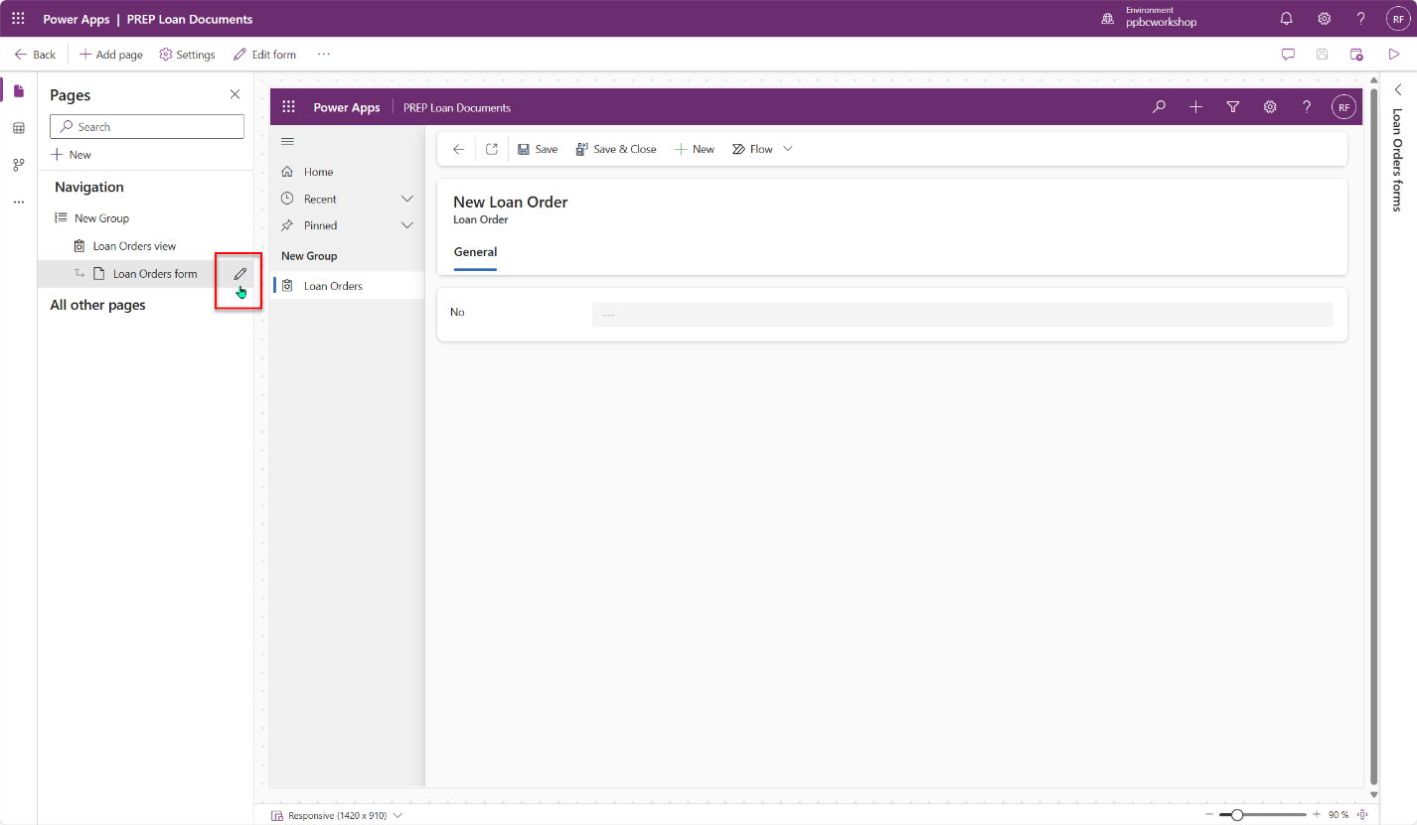
- Add sub grid and add table Loan Lines.
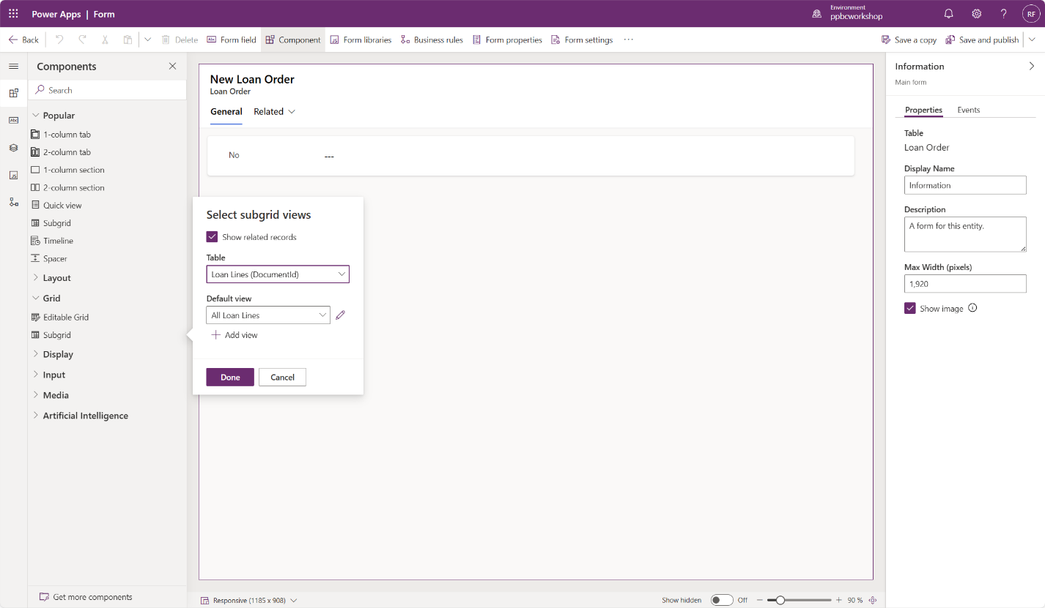
- Save and publish the form and return by selecting the Back button.
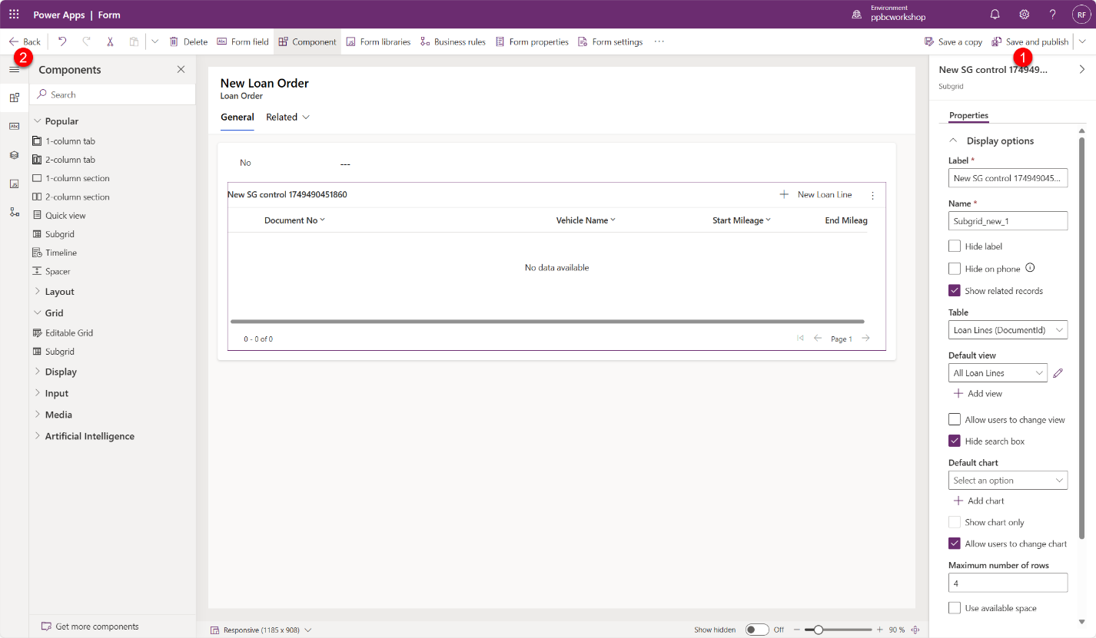
- Save and publish the application and test.
